
NATIONALITIES AND NUMBERS PRACTICE
WRITE THE FOLLOING NATIONALITIES:
- A person from United States is AMERICAN.
- A person from England is BRITISH
- A person from Brazil Is BRAZILIAN.
- A person from Japan is JAPANESSE.
- A person from Spain is SPANISH.
- A person from Canada is CANADIAN.
- A person from Russia is RUSSIAN.
- A person from China is CHINESE.
- A person from Australia is AUSTRALIAN.
- A person from Colombia is COLOMBIAN.
- A person from Italy is ITALIAN.
- A person from France is FRENCH.
- A person from Mexico is MEXICAN.
- A person from Germany is GERMAN.

WRITE THE FOLLOWING NUMBERS:
12.913: TWELVE THOUSAND NINE HUNDRED THIRTEEN
872: EIGHT HUNDRED SEVENTY-TWO
1.610: ONE THOUSAND SIX HUNDRED TEN
79: SEVENTY-NINE
140: ONE HUNDRED FORTY
25: TWENTY-FIVE
161: ONE HUNDRED SIXTY-ONE
5.333.222: FIVE MILLION THREE HUNDRED THIRTY-THREE THOUSAND TWO HUNDRED TWENTY-TWO

Personal Information Questions
Read the following questions in column A and match them with the right answer in Column B by writing the right number into the parenthesis.

(13) My email is YCRE.MZLES11@GMAIL.COM
(12) I was born in MANIZALES
(11) My nationality is COLOMBIAN.
(4) I live in CHIPRE.
(7) I am TWENTY-FOUR-YEARS-OLD
(3) My full name is YULY CATEHRINE ROJAS ECHEVERRI.
(15) I am SINGLE
(5) My phone number is 3126633365.
(9) I am a STUDENT
(2) My last name is ROJAS.
(8) I am at SENA.
(6) I am from MANIZALES.
(16) It is 1053835602.
(10) My birthday is on THREE OF MAY
(1) My first name is YULY
(14) I go to SENA.

What’s your first name?
What’s your last name?
What’s your full name?
Where do you live?
What’s your phone number?
Where are you from?
How old are you?
Where are you now?
What do you do?
When is your birthday?
What’s your nationality?
Where were your born?
What’s your email?
Where do you go to school?
What’s your marital Status?
What’s your ID number?


12 + 9
60 + 2
52 - 5
20 + 10
2 x 40
3 x 15
20\2
100 - 9
4 x 25
3\3
2 x 35
19 + 38
8\2
25 - 14
11 + 8
1
2
3
4
5
6
11
7
12
8
9
13
10
14
15
Y
O
T
W
E
N
O
-
Y
T
N
E
W
TW
1
T
SI
I
X
2
R
T
Y
S
E
V
N
-
O
F
3
T
V
I
Y
T
T
I
H
Y
T
H
G
I
4
5
E
F
O
F
R
-
6
N
E
7
E
D
N
I
N
E
T
Y
-
O
N
8
E
R
D
N
U
V
O
N
E
9
E
N
T
E
O
10
O
S
E
11
N
F
I
V
T
Y
-
V
E
E
12
E
R
U
13
N
E
V
L
14
N
I
T
E
E
N
15

ENGLISH
Numbers 0-100
Write the results in the crossword.

homework@live.dk

WEB GAMES
WHEN YOU FINISH EACH GAME, PLEASE COPY-PASTE THE SCREENSHOT
- http://www.eslgamesplus.com/countries-nationalities-esl-interactive-spelling-activity-online/
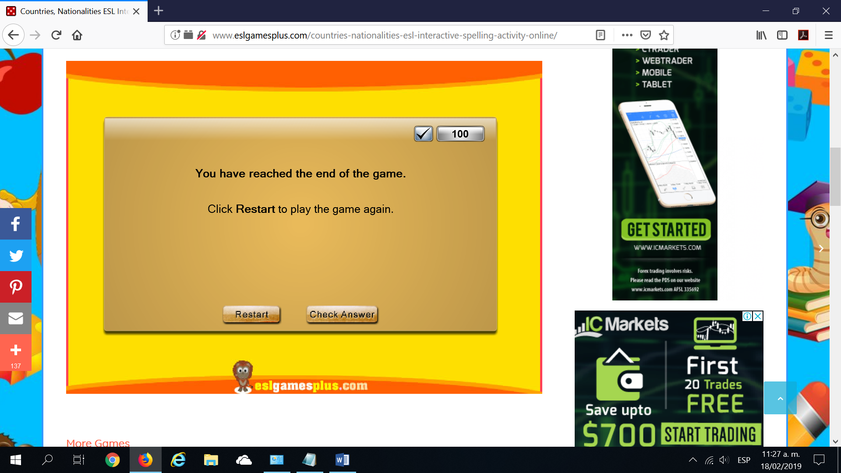

2.http://www.eslgamesplus.com/animals-colors-colours-clothes-numbers-english-vocabulary-game/
3.
http://www.eslgamesplus.com/numbers/

